Android 百分比布局库(percent-support-lib) 解析与扩展
android-percent-support这个库，基本可以解决上述问题，是不是有点小激动，稍等，我们先描述下这个support-lib。
这个库提供了：

两种布局供大家使用：
PercentRelativeLayout、PercentFrameLayout，通过名字就可以看出，这是继承自FrameLayout和RelativeLayout两个容器类；

支持的属性有：

layout_widthPercent、layout_heightPercent、
layout_marginPercent、layout_marginLeftPercent、
layout_marginTopPercent、layout_marginRightPercent、
layout_marginBottomPercent、layout_marginStartPercent、layout_marginEndPercent。
可以看到支持宽高，以及margin。
也就是说，大家只要在开发过程中使用PercentRelativeLayout、PercentFrameLayout替换FrameLayout、RelativeLayout即可。
是不是很简单，不过貌似没有LinearLayout，有人会说LinearLayout有weight属性呀。但是，weight属性只能支持一个方向呀~~哈，没事，刚好给我们一个机会去自定义一个PercentLinearLayout。

好了，本文分为3个部分：
PercentRelativeLayout、PercentFrameLayout的使用
对上述控件源码分析
自定义PercentLinearLayout

二、使用
关于使用，其实及其简单，并且github上也有例子，android-percent-support-lib-sample。我们就简单过一下：
首先记得在build.gradle添加：
compile 'com.android.support:percent:22.2.0'

（一）PercentFrameLayout
<?xml version="1.0" encoding="utf-8"?><android.support.percent.PercentFrameLayout xmlns:android="http://schemas.android.com/apk/res/android"
xmlns:app="http://schemas.android.com/apk/res-auto"
android:layout_width="match_parent"
android:layout_height="match_parent">

<TextView android:layout_width="0dp"
android:layout_height="0dp"
android:layout_gravity="left|top"
android:background="#44ff0000"
android:text="width:30%,height:20%"
app:layout_heightPercent="20%"
android:gravity="center"
app:layout_widthPercent="30%"/>

<TextView android:layout_width="0dp"
android:layout_height="0dp"
android:layout_gravity="right|top"
android:gravity="center"
android:background="#4400ff00"
android:text="width:70%,height:20%"
app:layout_heightPercent="20%"
app:layout_widthPercent="70%"/>

<TextView android:layout_width="0dp"
android:layout_height="0dp"
android:layout_gravity="bottom"
android:background="#770000ff"
android:text="width:100%,height:10%"
android:gravity="center"
app:layout_heightPercent="10%"
app:layout_widthPercent="100%"/>

</android.support.percent.PercentFrameLayout>

3个TextView，很简单，直接看效果图：
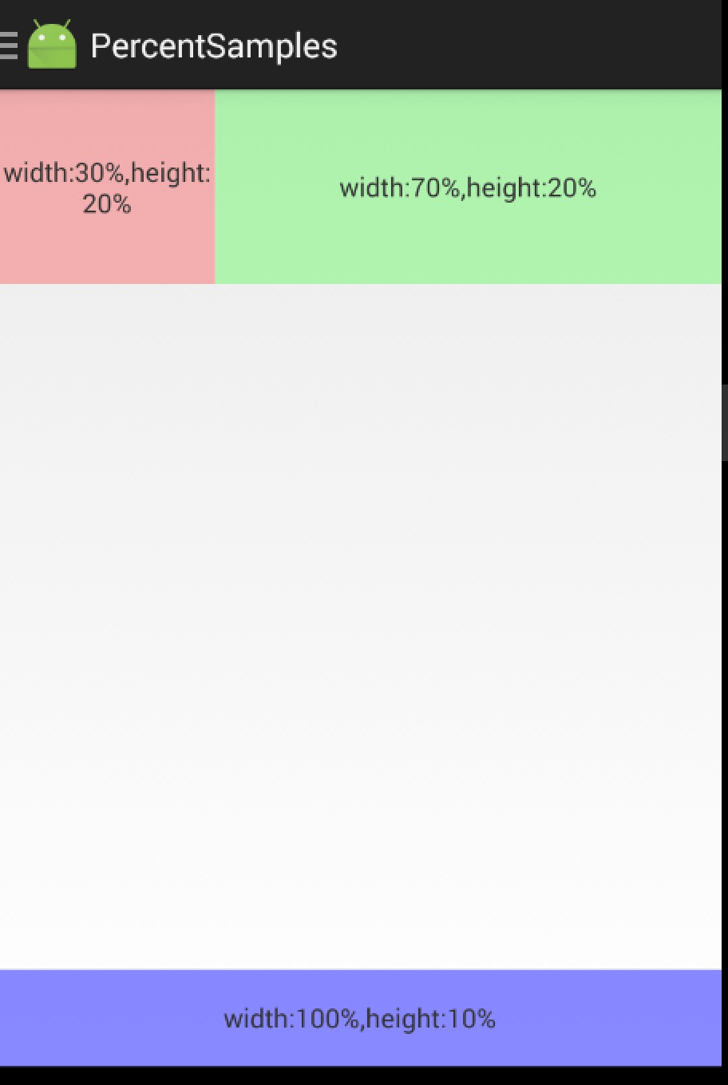

(二) PercentRelativeLayout
<?xml version="1.0" encoding="utf-8"?><android.support.percent.PercentRelativeLayout xmlns:android="http://schemas.android.com/apk/res/android"
xmlns:app="http://schemas.android.com/apk/res-auto"
android:layout_width="match_parent"
android:layout_height="match_parent"
android:clickable="true">

<TextView android:id="@+id/row_one_item_one"
android:layout_width="0dp"
android:layout_height="0dp"
android:layout_alignParentTop="true"
android:background="#7700ff00"
android:text="w:70%,h:20%"
android:gravity="center"
app:layout_heightPercent="20%"
app:layout_widthPercent="70%"/>

<TextView android:id="@+id/row_one_item_two"
android:layout_width="0dp"
android:layout_height="0dp"
android:layout_toRightOf="@+id/row_one_item_one"
android:background="#396190"
android:text="w:30%,h:20%"
app:layout_heightPercent="20%"
android:gravity="center"
app:layout_widthPercent="30%"/>

<ImageView android:id="@+id/row_two_item_one"
android:layout_width="match_parent"
android:layout_height="0dp"
android:src="@drawable/tangyan"
android:scaleType="centerCrop"
android:layout_below="@+id/row_one_item_one"
android:background="#d89695"
app:layout_heightPercent="70%"/>

<TextView android:layout_width="0dp"
android:layout_height="0dp"
android:layout_below="@id/row_two_item_one"
android:background="#770000ff"
android:gravity="center"
android:text="width:100%,height:10%"
app:layout_heightPercent="10%"
app:layout_widthPercent="100%"/>

</android.support.percent.PercentRelativeLayout>

ok，依然是直接看效果图:

使用没什么好说的，就是直观的看一下。

三、源码分析
其实细想一下，Google只是对我们原本熟悉的RelativeLayout和FrameLayout进行的功能的扩展，使其支持了percent相关的属性。
那么，我们考虑下，如果是我们添加这种扩展，我们会怎么做：
通过LayoutParams获取child设置的percent相关属性的值
onMeasure的时候，将child的width,height的值，通过获取的自定义属性的值进行计算（eg:容器的宽 * fraction ），计算后传入给child.measure(w,h);
ok，有了上面的猜想，我们直接看PercentFrameLayout的源码。
public class PercentFrameLayout extends FrameLayout {
private final PercentLayoutHelper mHelper = new PercentLayoutHelper(this);

//省略了，两个构造方法

public PercentFrameLayout(Context context, AttributeSet attrs) {
super(context, attrs);
}

@Override
public LayoutParams generateLayoutParams(AttributeSet attrs) {
return new LayoutParams(getContext(), attrs);
}

@Override
protected void onMeasure(int widthMeasureSpec, int heightMeasureSpec) {
mHelper.adjustChildren(widthMeasureSpec, heightMeasureSpec);
super.onMeasure(widthMeasureSpec, heightMeasureSpec);
if (mHelper.handleMeasuredStateTooSmall()) {
super.onMeasure(widthMeasureSpec, heightMeasureSpec);
}
}

@Override
protected void onLayout(boolean changed, int left, int top, int right, int bottom) {
super.onLayout(changed, left, top, right, bottom);
mHelper.restoreOriginalParams();
}

public static class LayoutParams extends FrameLayout.LayoutParams
implements PercentLayoutHelper.PercentLayoutParams {
private PercentLayoutHelper.PercentLayoutInfo mPercentLayoutInfo;

public LayoutParams(Context c, AttributeSet attrs) {
super(c, attrs);
mPercentLayoutInfo = PercentLayoutHelper.getPercentLayoutInfo(c, attrs);
}
//省略了一些代码...

@Override
public PercentLayoutHelper.PercentLayoutInfo getPercentLayoutInfo() {
return mPercentLayoutInfo;
}

@Override
protected void setBaseAttributes(TypedArray a, int widthAttr, int heightAttr) {
PercentLayoutHelper.fetchWidthAndHeight(this, a, widthAttr, heightAttr);
}
}
}

代码是相当的短，可以看到PercentFrameLayout里面首先重写了generateLayoutParams方法，当然了，由于支持了一些新的layout_属性，那么肯定需要定义对应的LayoutParams。

（一）percent相关属性的获取
可以看到PercentFrameLayout.LayoutParams在原有的FrameLayout.LayoutParams基础上，实现了PercentLayoutHelper.PercentLayoutParams接口。
这个接口很简单，只有一个方法：
public interface PercentLayoutParams {
PercentLayoutInfo getPercentLayoutInfo();
}

而，这个方法的实现呢，也只有一行：return mPercentLayoutInfo;，那么这个mPercentLayoutInfo在哪完成赋值呢？
看PercentFrameLayout.LayoutParams的构造方法：
public LayoutParams(Context c, AttributeSet attrs) {
super(c, attrs);
mPercentLayoutInfo = PercentLayoutHelper.getPercentLayoutInfo(c, attrs);
}

可以看到，将attrs传入给getPercentLayoutInfo方法，那么不用说，这个方法的内部，肯定是获取自定义属性的值，然后将其封装到PercentLayoutInfo对象中，最后返回。
代码如下：
public static PercentLayoutInfo getPercentLayoutInfo(Context context,
AttributeSet attrs) {
PercentLayoutInfo info = null;
TypedArray array = context.obtainStyledAttributes(attrs, R.styleable.PercentLayout_Layout);
float value = array.getFraction(R.styleable.PercentLayout_Layout_layout_widthPercent, 1, 1,
-1f);
if (value != -1f) {
if (Log.isLoggable(TAG, Log.VERBOSE)) {
Log.v(TAG, "percent width: " + value);
}
info = info != null ? info : new PercentLayoutInfo();
info.widthPercent = value;
}
value = array.getFraction(R.styleable.PercentLayout_Layout_layout_heightPercent, 1, 1, -1f);
if (value != -1f) {
if (Log.isLoggable(TAG, Log.VERBOSE)) {
Log.v(TAG, "percent height: " + value);
}
info = info != null ? info : new PercentLayoutInfo();
info.heightPercent = value;
}
value = array.getFraction(R.styleable.PercentLayout_Layout_layout_marginPercent, 1, 1, -1f);
if (value != -1f) {
if (Log.isLoggable(TAG, Log.VERBOSE)) {
Log.v(TAG, "percent margin: " + value);
}
info = info != null ? info : new PercentLayoutInfo();
info.leftMarginPercent = value;
info.topMarginPercent = value;
info.rightMarginPercent = value;
info.bottomMarginPercent = value;
}
value = array.getFraction(R.styleable.PercentLayout_Layout_layout_marginLeftPercent, 1, 1,
-1f);
if (value != -1f) {
if (Log.isLoggable(TAG, Log.VERBOSE)) {
Log.v(TAG, "percent left margin: " + value);
}
info = info != null ? info : new PercentLayoutInfo();
info.leftMarginPercent = value;
}
value = array.getFraction(R.styleable.PercentLayout_Layout_layout_marginTopPercent, 1, 1,
-1f);
if (value != -1f) {
if (Log.isLoggable(TAG, Log.VERBOSE)) {
Log.v(TAG, "percent top margin: " + value);
}
info = info != null ? info : new PercentLayoutInfo();
info.topMarginPercent = value;
}
value = array.getFraction(R.styleable.PercentLayout_Layout_layout_marginRightPercent, 1, 1,
-1f);
if (value != -1f) {
if (Log.isLoggable(TAG, Log.VERBOSE)) {
Log.v(TAG, "percent right margin: " + value);
}
info = info != null ? info : new PercentLayoutInfo();
info.rightMarginPercent = value;
}
value = array.getFraction(R.styleable.PercentLayout_Layout_layout_marginBottomPercent, 1, 1,
-1f);
if (value != -1f) {
if (Log.isLoggable(TAG, Log.VERBOSE)) {
Log.v(TAG, "percent bottom margin: " + value);
}
info = info != null ? info : new PercentLayoutInfo();
info.bottomMarginPercent = value;
}
value = array.getFraction(R.styleable.PercentLayout_Layout_layout_marginStartPercent, 1, 1,
-1f);
if (value != -1f) {
if (Log.isLoggable(TAG, Log.VERBOSE)) {
Log.v(TAG, "percent start margin: " + value);
}
info = info != null ? info : new PercentLayoutInfo();
info.startMarginPercent = value;
}
value = array.getFraction(R.styleable.PercentLayout_Layout_layout_marginEndPercent, 1, 1,
-1f);
if (value != -1f) {
if (Log.isLoggable(TAG, Log.VERBOSE)) {
Log.v(TAG, "percent end margin: " + value);
}
info = info != null ? info : new PercentLayoutInfo();
info.endMarginPercent = value;
}
array.recycle();
if (Log.isLoggable(TAG, Log.DEBUG)) {
Log.d(TAG, "constructed: " + info);
}
return info;
}

是不是和我们平时的取值很类似，所有的值最终封装到PercentLayoutInfo对象中。
ok，到此我们的属性获取就介绍完成，有了这些属性，是不是onMeasure里面要进行使用呢？

(二) onMeasue中重新计算child的尺寸
@Override
protected void onMeasure(int widthMeasureSpec, int heightMeasureSpec) {
mHelper.adjustChildren(widthMeasureSpec, heightMeasureSpec);
super.onMeasure(widthMeasureSpec, heightMeasureSpec);
if (mHelper.handleMeasuredStateTooSmall()) {
super.onMeasure(widthMeasureSpec, heightMeasureSpec);
}
}

可以看到onMeasure中的代码页很少，看来核心的代码都被封装在mHelper的方法中，我们直接看mHelper.adjustChildren方法。
/**
* Iterates over children and changes their width and height to one calculated from percentage
* values.
* @param widthMeasureSpec Width MeasureSpec of the parent ViewGroup.
* @param heightMeasureSpec Height MeasureSpec of the parent ViewGroup.
*/
public void adjustChildren(int widthMeasureSpec, int heightMeasureSpec) {
//...
int widthHint = View.MeasureSpec.getSize(widthMeasureSpec);
int heightHint = View.MeasureSpec.getSize(heightMeasureSpec);
for (int i = 0, N = mHost.getChildCount(); i < N; i++) {
View view = mHost.getChildAt(i);
ViewGroup.LayoutParams params = view.getLayoutParams();

if (params instanceof PercentLayoutParams) {
PercentLayoutInfo info =
((PercentLayoutParams) params).getPercentLayoutInfo();
if (Log.isLoggable(TAG, Log.DEBUG)) {
Log.d(TAG, "using " + info);
}
if (info != null) {
if (params instanceof ViewGroup.MarginLayoutParams) {
info.fillMarginLayoutParams((ViewGroup.MarginLayoutParams) params,
widthHint, heightHint);
} else {
info.fillLayoutParams(params, widthHint, heightHint);
}
}
}
}
}

通过注释也能看出，此方法中遍历所有的孩子，通过百分比的属性重新设置其宽度和高度。
首先在widthHint、heightHint保存容器的宽、高，然后遍历所有的孩子，判断其LayoutParams是否是PercentLayoutParams类型，如果是，通过params.getPercentLayoutInfo拿出info对象。
是否还记得，上面的分析中，PercentLayoutInfo保存了percent相关属性的值。
如果info不为null，则判断是否需要处理margin；我们直接看fillLayoutParams方法（处理margin也是类似的）。
/**
* Fills {@code ViewGroup.LayoutParams} dimensions based on percentage values.
*/
public void fillLayoutParams(ViewGroup.LayoutParams params, int widthHint,
int heightHint) {
// Preserve the original layout params, so we can restore them after the measure step.
mPreservedParams.width = params.width;
mPreservedParams.height = params.height;

if (widthPercent >= 0) {
params.width = (int) (widthHint * widthPercent);
}
if (heightPercent >= 0) {
params.height = (int) (heightHint * heightPercent);
}
if (Log.isLoggable(TAG, Log.DEBUG)) {
Log.d(TAG, "after fillLayoutParams: (" + params.width + ", " + params.height + ")");
}
}

首先保存原本的width和height，然后重置params的width和height为(int) (widthHint * widthPercent)和(int) (heightHint * heightPercent);。
到此，其实我们的百分比转换就结束了，理论上就已经实现了对于百分比的支持，不过Google还考虑了一些细节。
我们回到onMeasure方法：
@Override
protected void onMeasure(int widthMeasureSpec, int heightMeasureSpec) {
mHelper.adjustChildren(widthMeasureSpec, heightMeasureSpec);
super.onMeasure(widthMeasureSpec, heightMeasureSpec);
if (mHelper.handleMeasuredStateTooSmall()) {
super.onMeasure(widthMeasureSpec, heightMeasureSpec);
}
}

下面还有个mHelper.handleMeasuredStateTooSmall的判断，也就是说，如果你设置的百分比，最终计算出来的MeasuredSize过小的话，会进行一些操作。
代码如下：
public boolean handleMeasuredStateTooSmall() {
boolean needsSecondMeasure = false;
for (int i = 0, N = mHost.getChildCount(); i < N; i++) {
View view = mHost.getChildAt(i);
ViewGroup.LayoutParams params = view.getLayoutParams();
if (Log.isLoggable(TAG, Log.DEBUG)) {
Log.d(TAG, "should handle measured state too small " + view + " " + params);
}
if (params instanceof PercentLayoutParams) {
PercentLayoutInfo info =
((PercentLayoutParams) params).getPercentLayoutInfo();
if (info != null) {
if (shouldHandleMeasuredWidthTooSmall(view, info)) {
needsSecondMeasure = true;
params.width = ViewGroup.LayoutParams.WRAP_CONTENT;
}
if (shouldHandleMeasuredHeightTooSmall(view, info)) {
needsSecondMeasure = true;
params.height = ViewGroup.LayoutParams.WRAP_CONTENT;
}
}
}
}
if (Log.isLoggable(TAG, Log.DEBUG)) {
Log.d(TAG, "should trigger second measure pass: " + needsSecondMeasure);
}
return needsSecondMeasure;
}

首先遍历所有的孩子，拿出孩子的layoutparams，如果是PercentLayoutParams实例，则取出info。如果info不为null，调用shouldHandleMeasuredWidthTooSmall判断：
private static boolean shouldHandleMeasuredWidthTooSmall(View view, PercentLayoutInfo info) {
int state = ViewCompat.getMeasuredWidthAndState(view) & ViewCompat.MEASURED_STATE_MASK;
return state == ViewCompat.MEASURED_STATE_TOO_SMALL && info.widthPercent >= 0 &&
info.mPreservedParams.width == ViewGroup.LayoutParams.WRAP_CONTENT;
}

这里就是判断，如果你设置的measuredWidth或者measureHeight过小的话，并且你在布局文件中layout_w/h 设置的是WRAP_CONTENT的话，将params.width / height= ViewGroup.LayoutParams.WRAP_CONTENT，然后重新测量。
哈，onMeasure终于结束了~~~现在我觉得应该代码结束了吧，尺寸都设置好了，还需要干嘛么，but，你会发现onLayout也重写了，我们又不改变layout规则，在onLayout里面干什么毛线：
@Override
protected void onLayout(boolean changed, int left, int top, int right, int bottom) {
super.onLayout(changed, left, top, right, bottom);
mHelper.restoreOriginalParams();
}

继续看mHelper.restoreOriginalParams
/**
* Iterates over children and restores their original dimensions that were changed for
* percentage values. Calling this method only makes sense if you previously called
* {@link PercentLayoutHelper#adjustChildren(int, int)}.
*/
public void restoreOriginalParams() {
for (int i = 0, N = mHost.getChildCount(); i < N; i++) {
View view = mHost.getChildAt(i);
ViewGroup.LayoutParams params = view.getLayoutParams();
if (Log.isLoggable(TAG, Log.DEBUG)) {
Log.d(TAG, "should restore " + view + " " + params);
}
if (params instanceof PercentLayoutParams) {
PercentLayoutInfo info =
((PercentLayoutParams) params).getPercentLayoutInfo();
if (Log.isLoggable(TAG, Log.DEBUG)) {
Log.d(TAG, "using " + info);
}
if (info != null) {
if (params instanceof ViewGroup.MarginLayoutParams) {
info.restoreMarginLayoutParams((ViewGroup.MarginLayoutParams) params);
} else {
info.restoreLayoutParams(params);
}
}
}
}
}

噗，原来是重新恢复原本的尺寸值，也就是说onMeasure里面的对值进行了改变，测量完成后。在这个地方，将值又恢复成如果布局文件中的值，上面写的都是0。恢复很简单：
public void restoreLayoutParams(ViewGroup.LayoutParams params) {
params.width = mPreservedParams.width;
params.height = mPreservedParams.height;
}

你应该没有忘在哪存的把~忘了的话，麻烦Ctrl+F ‘mPreservedParams.width’ 。
也就是说，你去打印上面写法，布局文件中view的v.getLayoutParams().width，这个值应该是0。
这里感觉略微不爽~这个0没撒用处呀，还不如不重置~~
好了，到此就分析完了，其实主要就几个步骤：
LayoutParams中属性的获取
onMeasure中，改变params.width为百分比计算结果，测量
如果测量值过小且设置的w/h是wrap_content，重新测量
onLayout中，重置params.w/h为布局文件中编写的值
可以看到，有了RelativeLayout、FrameLayout的扩展，竟然没有LinearLayout几个意思。好在，我们的核心代码都由PercentLayoutHelper封装了，自己扩展下LinearLayout也不复杂。

三、实现PercentLinearlayout
可能有人会说，有了weight呀，但是weight能做到宽、高同时百分比赋值嘛？
好了，代码很简单，如下：

（一）PercentLinearLayout
package com.juliengenoud.percentsamples;
import android.content.Context;import android.content.res.TypedArray;import android.support.percent.PercentLayoutHelper;import android.util.AttributeSet;import android.view.ViewGroup;import android.widget.LinearLayout;
/**
* Created by zhy on 15/6/30.
*/public class PercentLinearLayout extends LinearLayout
{

private PercentLayoutHelper mPercentLayoutHelper;

public PercentLinearLayout(Context context, AttributeSet attrs)
{
super(context, attrs);

mPercentLayoutHelper = new PercentLayoutHelper(this);
}

@Override
protected void onMeasure(int widthMeasureSpec, int heightMeasureSpec)
{
mPercentLayoutHelper.adjustChildren(widthMeasureSpec, heightMeasureSpec);
super.onMeasure(widthMeasureSpec, heightMeasureSpec);
if (mPercentLayoutHelper.handleMeasuredStateTooSmall())
{
super.onMeasure(widthMeasureSpec, heightMeasureSpec);
}
}

@Override
protected void onLayout(boolean changed, int l, int t, int r, int b)
{
super.onLayout(changed, l, t, r, b);
mPercentLayoutHelper.restoreOriginalParams();
}

@Override
public LayoutParams generateLayoutParams(AttributeSet attrs)
{
return new LayoutParams(getContext(), attrs);
}

public static class LayoutParams extends LinearLayout.LayoutParams
implements PercentLayoutHelper.PercentLayoutParams
{
private PercentLayoutHelper.PercentLayoutInfo mPercentLayoutInfo;

public LayoutParams(Context c, AttributeSet attrs)
{
super(c, attrs);
mPercentLayoutInfo = PercentLayoutHelper.getPercentLayoutInfo(c, attrs);
}

@Override
public PercentLayoutHelper.PercentLayoutInfo getPercentLayoutInfo()
{
return mPercentLayoutInfo;
}

@Override
protected void setBaseAttributes(TypedArray a, int widthAttr, int heightAttr)
{
PercentLayoutHelper.fetchWidthAndHeight(this, a, widthAttr, heightAttr);
}

public LayoutParams(int width, int height) {
super(width, height);
}

public LayoutParams(ViewGroup.LayoutParams source) {
super(source);
}

public LayoutParams(MarginLayoutParams source) {
super(source);
}

}

}

如果你详细看了上面的源码分析，这个代码是不是没撒解释的了~

（二）测试布局
<?xml version="1.0" encoding="utf-8"?>

<com.juliengenoud.percentsamples.PercentLinearLayout xmlns:android="http://schemas.android.com/apk/res/android"
xmlns:app="http://schemas.android.com/apk/res-auto"
android:layout_width="match_parent"
android:layout_height="match_parent"
android:orientation="vertical">

<TextView android:layout_width="0dp"
android:layout_height="0dp"
android:background="#ff44aacc"
android:text="width:60%,height:5%"
android:textColor="#ffffff"
app:layout_heightPercent="5%"
app:layout_marginBottomPercent="5%"
app:layout_widthPercent="60%"/>

<TextView android:layout_width="0dp"
android:layout_height="0dp"
android:background="#ff4400cc"
android:gravity="center"
android:textColor="#ffffff"
android:text="width:70%,height:10%"
app:layout_heightPercent="10%"
app:layout_marginBottomPercent="5%"
app:layout_widthPercent="70%"/>
<TextView android:layout_width="0dp"
android:layout_height="0dp"
android:background="#ff44aacc"
android:gravity="center"
android:text="width:80%,height:15%"
android:textColor="#ffffff"
app:layout_heightPercent="15%"
app:layout_marginBottomPercent="5%"
app:layout_widthPercent="80%"/>
<TextView android:layout_width="0dp"
android:layout_height="0dp"
android:background="#ff4400cc"
android:gravity="center"
android:text="width:90%,height:5%"
android:textColor="#ffffff"
app:layout_heightPercent="20%"
app:layout_marginBottomPercent="10%"
app:layout_widthPercent="90%"/>

<TextView android:layout_width="match_parent"
android:layout_height="0dp"
android:background="#ff44aacc"
android:gravity="center"
android:text="width:100%,height:25%"
android:textColor="#ffffff"
app:layout_heightPercent="25%"
app:layout_marginBottomPercent="5%"
/>

</com.juliengenoud.percentsamples.PercentLinearLayout>

我们纵向排列的几个TextView，分别设置宽/高都为百分比，且之间的间隔为5%p。

(三)效果图
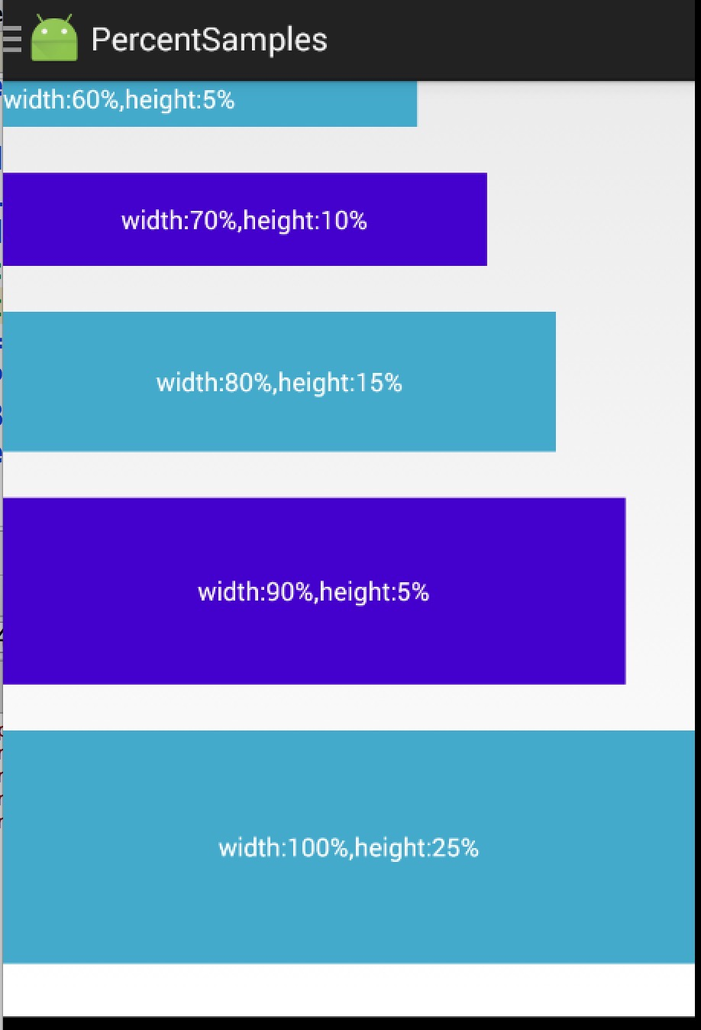
ok，到此，我们使用、源码分析、扩展PercentLinearLayout就结束了。
添加PercentLinearLayout后的地址：点击查看
扩展下载:android-percent-support-extend 包含android studio, eclipse项目，以及上述源码。

